Game Design Document

Fill up the following document

1. Write the title of your project.

The title of my game is “ NINJA ON HUNT .“

1. What is the goal of the game?

So the goal of the game is that we have to to jump on the bricks , collect all

Coins , kill all the monsters and get the magical sword in the end .

1. Write a brief story of your game.

So the brief story of the game is that there is a ninja who has heard about a

Sword which was stolen by the most 3 most deadly and scary monsters

Who had stolen the sword . Nobody in 1,000 years has ever wielded it .

Can you ????

1. Which are the playing characters of this game?

* Playing characters are the ones who respond to the user based on the input from the user.
* Cars, monkeys, dinos, wizards, etc., are the playing characters in the game.

|  |  |  |
| --- | --- | --- |
| Number | Character Name | What can this character do? |
| 1 | Ninja player | The character can jump on bricks , kill the monsters , and collect all the coins.He has to kill the monsters using 3 ninja stars. |
| 2 |  |  |
| 3 |  |  |
| 4 |  |  |
| 5 |  |  |
| 6 |  |  |
| 7 |  |  |
| 8 |  |  |

1. Which are the Non-Playing Characters of this game?

* Non-Playing characters are the ones that don't have an action or behavior when the user interacts with the game.
* Hurdles, stones, bananas, coins, etc., are non-playing characters in the game.

|  |  |  |
| --- | --- | --- |
| Number | Character Name | What can this character do? |
| 1 | Monster eye | Shoots big eyes at the player with nomal speed |
| 2 | monster air | He can shoot projectiles with the speed of air ands moving right to left |
| 3 | Monster king | He shoots slime balls towards the player with tremendeous speed and also moves very fast |
| 4 | bricks | You have to jump on bricks ad go react to the sword |
| 5 | Coins | You have to collect coins as you move upwards |
| 6 |  |  |
| 7 |  |  |
| 8 |  |  |

* Draw the game either on your computer or on paper
* 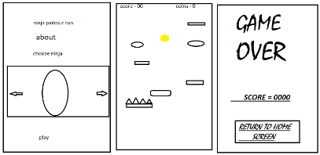
* Add images of the game scenes to show each of the playing and non-playing characters at least once.

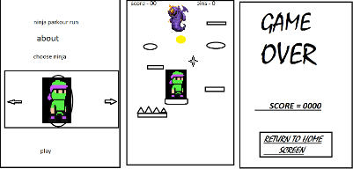

How do you plan to make your game engaging?

The game keeps the player so engrossed so he does not want a free fall and he finally meets his goal of becoming a Ninja Samurai